Shannon Bonner

[bonnersh@gmail.com](mailto:bonnersh@gmail.com)

I am enclosing 2 lesson plans for a High School level art class; one for Crafts and the other for Advanced Ceramics. Each project contains “Quality Standards,” a term in which my students are familiar. You will notice that these standards are specific and observable. No “touchy-feely” terms like “creative,” “aesthetically pleasing”, or “beautiful” are used. Do these things count in art? YES! However, they are subjective and difficult to define. So, the project standards concentrate on qualities which can be taught and demonstrated specifically in class, and which are objectively observable. More subjective elements of art, like those mentioned in the project descriptions, are considered, but only for “exceeding standards.”

In addition I always purchase art items to use in the classroom for reference. There is nothing like seeing art in the flesh and this can inspire students to imitate. I believe this is a strong learning tool in understanding and appreciating the artwork of a culture, people or nation. Another method to create student interest is with displays that feature the work of another country. Since the display area is in the art wing, art of the culture is always prominently featured along with icons and interesting facts. 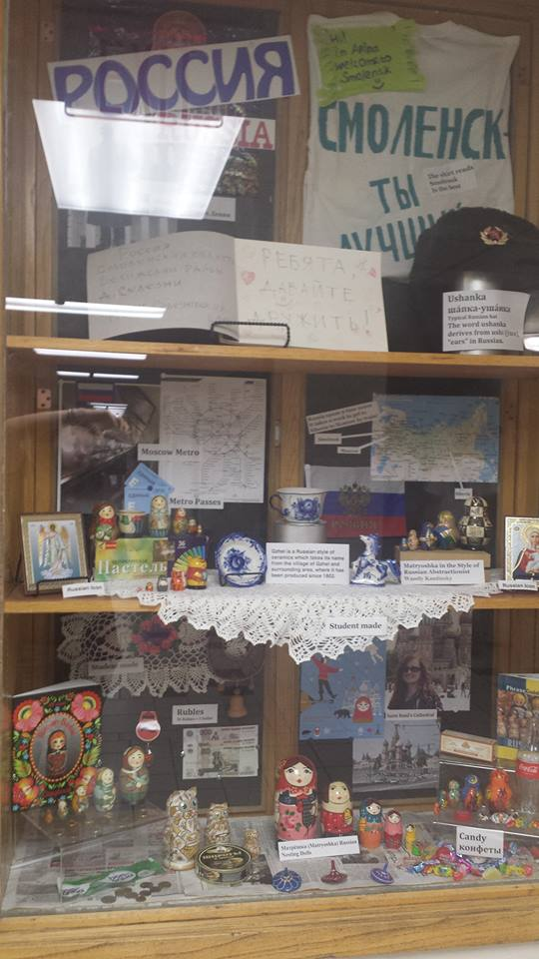

Currently, I teach Introduction to Art, Ceramics and Advanced Ceramics. These classes are considered electives, meaning that, ideally, the students choose to take my classes. Realistically however, that isn’t always the case. It is my responsibility to win over all of my students and convince them that art classes can be relevant to their lives. This can be accomplished through a broad and well-designed curriculum development process. I will incorporate my experiences as we review and design the next version of our art curriculum. As a college student and educator, I purposely sought out experiences that furthered self-awareness. My cultural experiences have had a strong impact on how I view our global society. This desire has manifested itself over and over in my career as a teacher. I believe that educators, scholars, and artists must have the desire, capacity, and tools necessary to nurture a sense of common purpose. Art and history are the mediums through which the bonds among the world’s races, religions, cultures and traditions are established. My long-term goal is to share my passion for art with my students.