Bonner

Crafts

**Faberge Egg Painting**

After viewing the power point about the history of Faberge Eggs, you will create your own version of this style of egg. Faberge eggs were ornate and created with metals, some eggs even opened to reveal sculptures or pictures inside. For this project however, you will be using a wooden egg and stand so you will need to focus on color and design.

Think about the lines you saw on the eggs. Some eggs were banded, some had cross hatched lines, others had circles, floral designs, scalloped edges, swirls, tear drops, combinations, just to name a few.

I will make available wooden eggs with stands, fine detail brushes, all colors of tempra paints and silver, gold and bronze paints. If you choose later, after your design is painted, you can glue tiny jewel details to your egg.

This project is challenging because these eggs were crafted in metal, gold, silver and precious jewels and you are not only painting a design(s) but it’s on a convex surface.

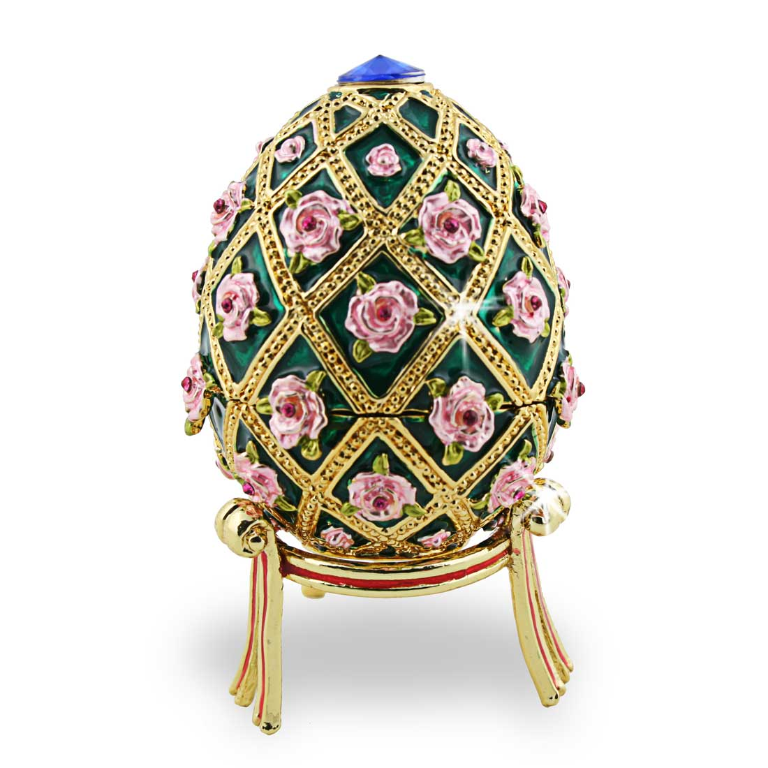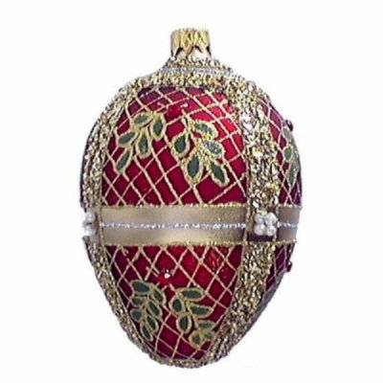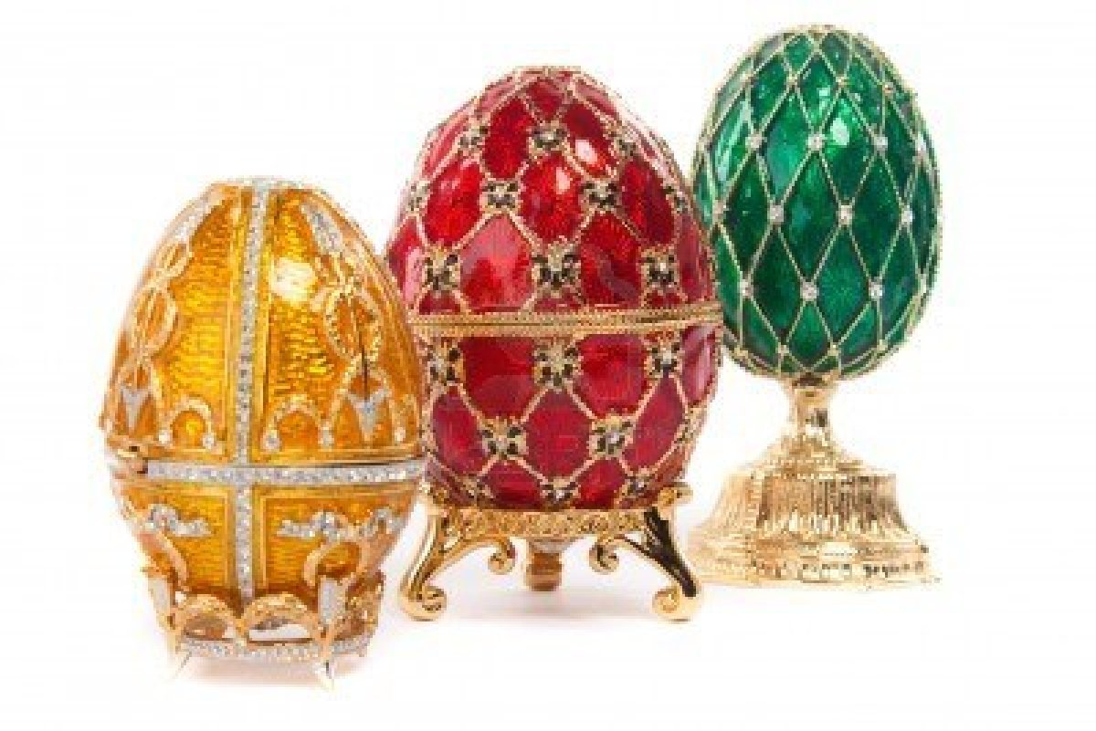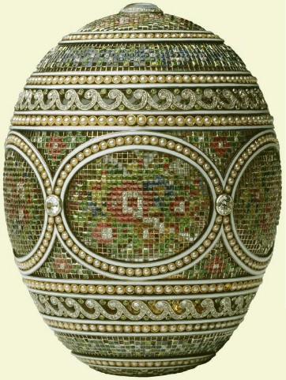

**Quality Standards**

1. Preliminary sketch approved before beginning
2. 3 color minimum
3. One repeating pattern
4. One egg and one stand full painted
5. Line Design—able to identify types of lines
6. Complexity and craftsmanship

Bonner

Advanced Ceramics 1 & 2

**Matryoshka or Russian Nesting Dolls**

Matryoshka dolls are often designed to follow a particular theme, for instance, peasant girls in traditional dress. Originally themes often drew from tradition or [fairy tale](http://en.wikipedia.org/wiki/Fairy_tale) characters in keeping with the craft tradition, but recently, they have embraced a larger range, including [Soviet](http://en.wikipedia.org/wiki/Soviet_Union) leaders and figures from popular culture.

Modern artists create many new styles of nesting dolls. Common themes include floral, [Christmas](http://en.wikipedia.org/wiki/Christmas), [Easter](http://en.wikipedia.org/wiki/Easter), religious, animal collections, portraits and [caricatures](http://en.wikipedia.org/wiki/Caricatures) of famous politicians, musicians, athletes, astronauts, "robots," and popular movie stars. Matryoshka dolls that featured communist leaders of Russia became very popular among Russian people in the early 1990s, after the collapse of the Soviet Union. Today, some Russian artists specialize in painting themed matryoshka dolls that feature specific categories of subjects, people or nature.

These nesting dolls are made out of wood and the figures are traditionally not less than five so since we are using clay and not wood- your challenge is to make a set of 3 that “nest.”

See classroom Examples

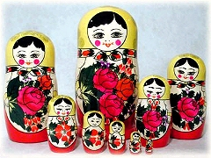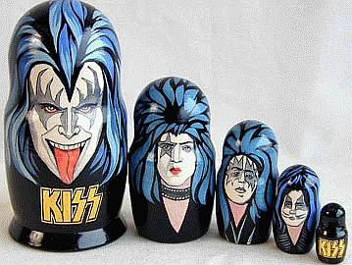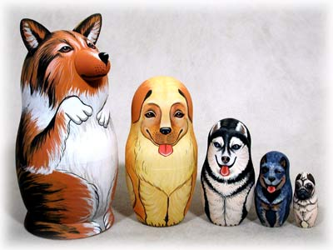

**Quality Standards**

1. 1 nesting doll (additional dolls for exceeding this standard)
2. The largest doll needs to be 7-8 inches in height
3. Any method(s) of construction
4. Keepers on each doll
5. Theme—all dolls match- could be traditional or from popular culture
6. Minimum of 3 glazes